Notes on Working on Your Practice Card

NB: Please note all changes on a Practice Card will update on the website the next day as part of a nightly task.
https://portfolio.surgeons.org

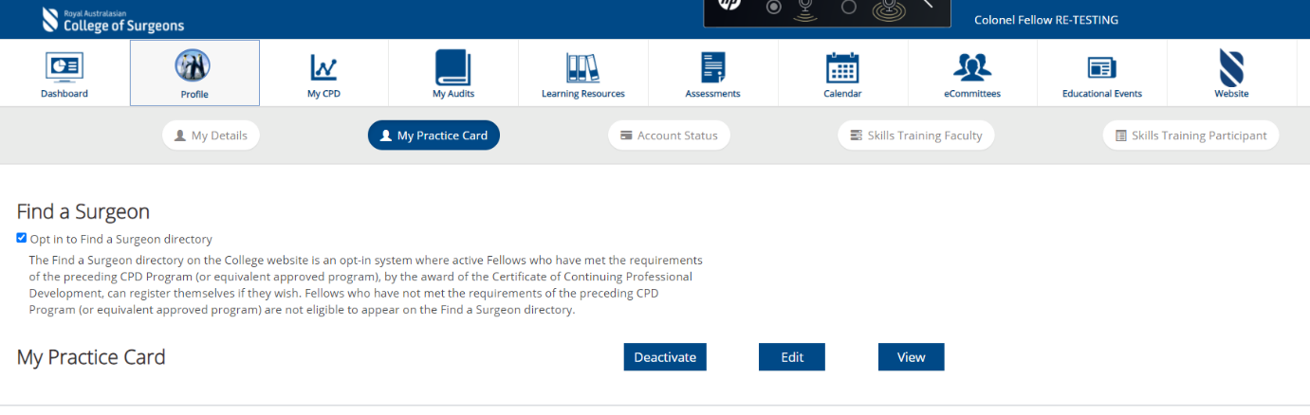

To activate a practice card, please ensure that the opt in checkbox is ticked. Once done, click on the edit button to get started creating your practice card.

Where you can edit your details
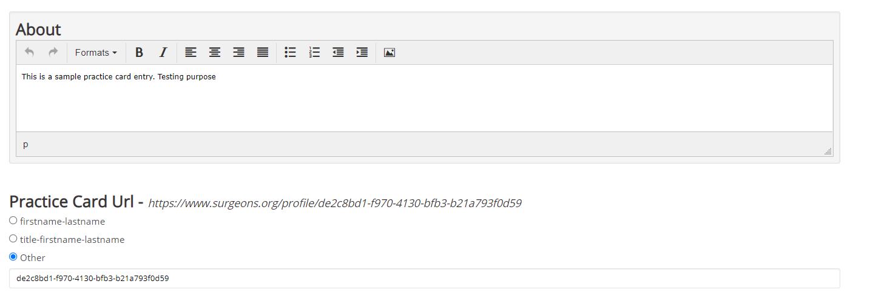

When Creating a Consulting Room you need to make sure you set your email and contact number in your consulting room. If you do not do this, the contact number / email address will pull in your primary email (sometimes personal email address)
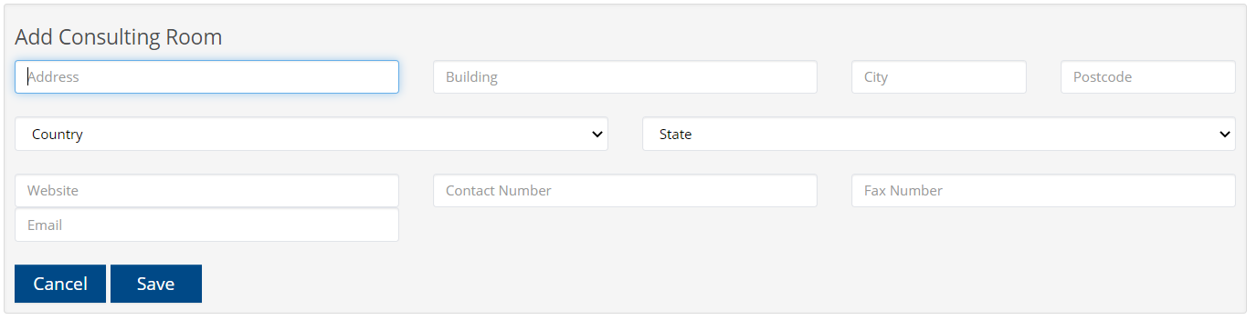
Example record you should enter in
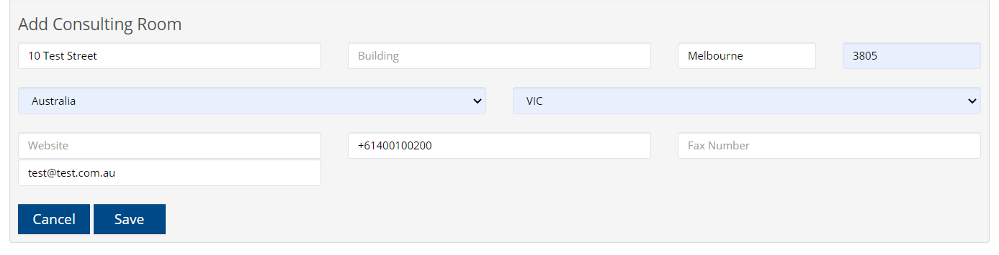
As shown the first textbox provides an assisted address drop down which will automatically populate the related fields.
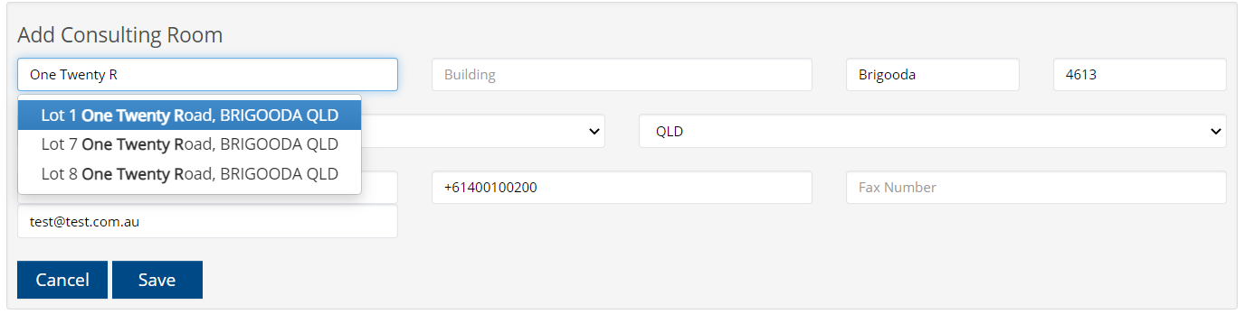
Setting your address as Featured, will generate a relevant Google Map with pin marker for given address.

Information about Areas of Practice, Professional Qualifications, Specialty and Professional Associations
These details are separate than the details present else where in your portfolio. These are directly related to your practice card. If you find that your practice card doesn’t have the relevant details below. Make sure you have set them up in your practice card and not ehub.
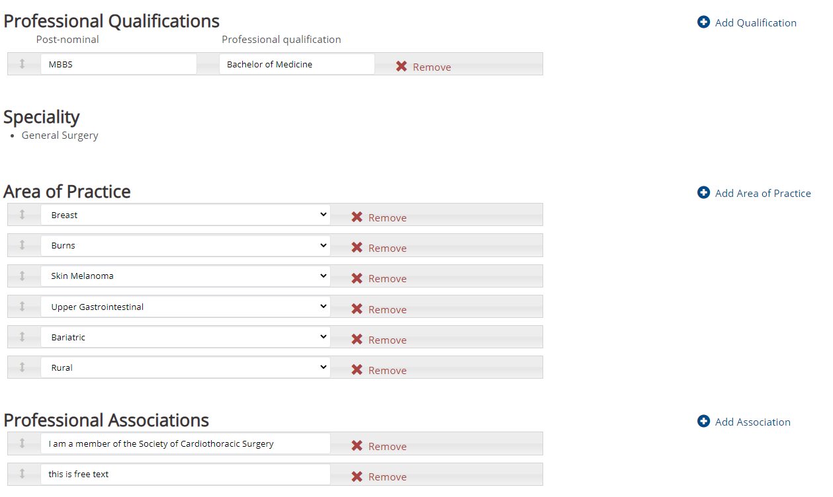
As you can see inside ehub.surgeons.org on the next page, this fellow has his qualifications set, but they do not match to the qualifications above as they have to be set independently.
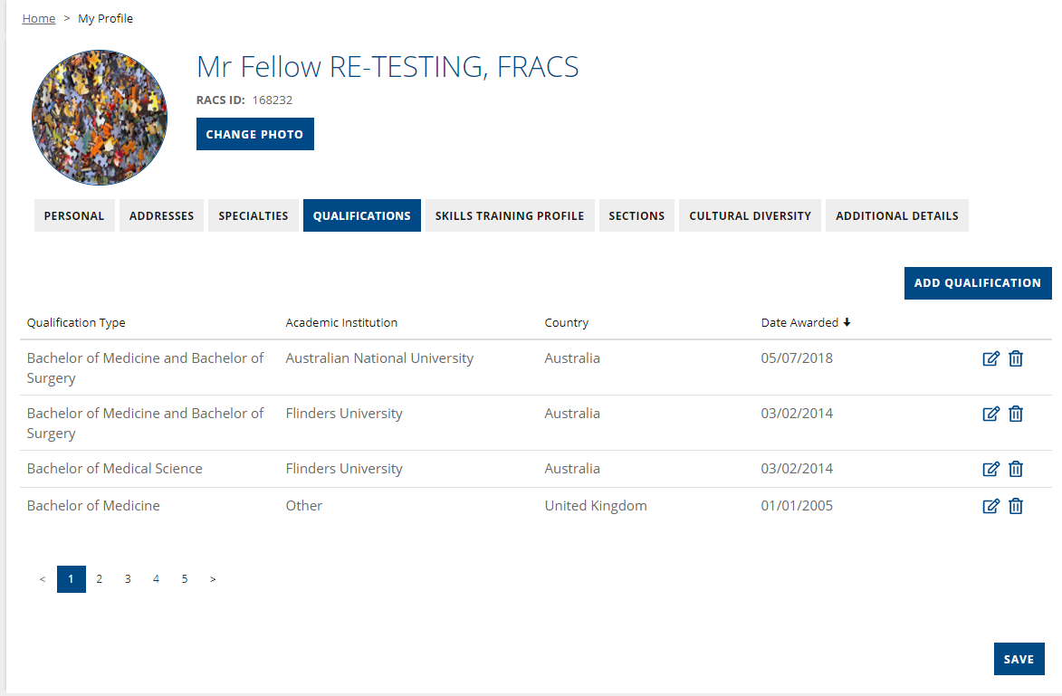

Another example of differing qualifications so as to not confuse qualifications set on practice card with those set on the qualifications shown on ehub.

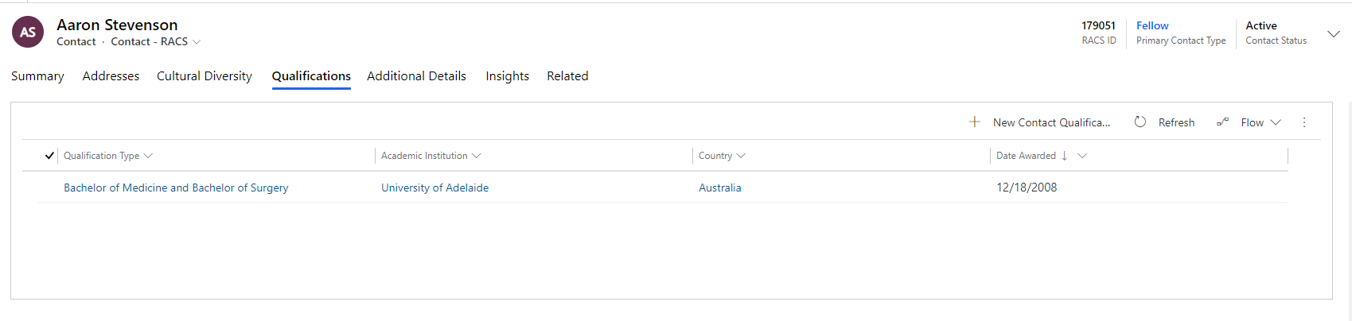
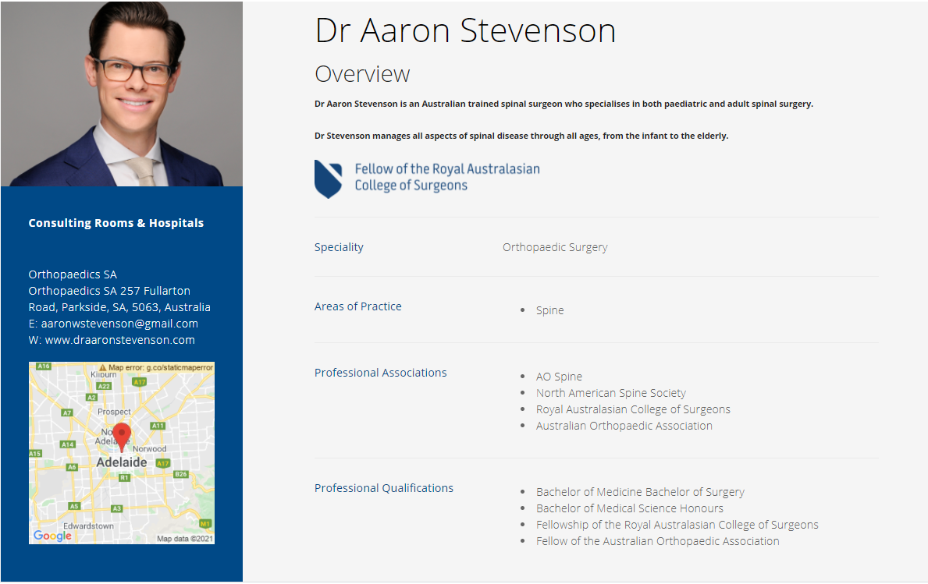
The Logos at the bottom of the Practice Card screen are not functioning currently. So there is no point in setting them up.
