OBITUARY

DR MERVYN JOHN CROSS OAM FRACS FACSEP(Hon)
ORTHOPAEDIC SURGEON and RUGBY LEAGUE FOOTBALLER
3 JULY 1941 – 25 AUGUST 2023

Sadly, ASOS director and past Chairman Dr Merv Cross OAM passed away on Friday night after a long battle with lung disease. He was 82.  There are no words that can rightly express the deep affection and gratitude that many of his colleagues, patients and friends share for the man we knew as “Merv”.  Dr Merv Cross replaced Dr Bruce Shepherd as Chairman of ASOS in 1989. He was one of the 68 ‘Immortals’ – doctors who resigned their public hospital appointments during the 1984 Doctors’ Dispute. He was an honorary orthopaedic surgeon in the NSW public hospital system for many years.  In the last 100 years, only five people have played professional rugby and successfully graduated as doctors. Dr Cross was one of them. It was therefore no surprise that Dr Cross would go on to become one of the medical profession’s most outstanding Knee Surgeons, after pioneering arthroscopic surgery and anterior cruciate ligament reconstruction in Australia. His clinical standing was exemplified with his appointment as Director of Orthopaedics for the Sydney 2000 Olympics. | 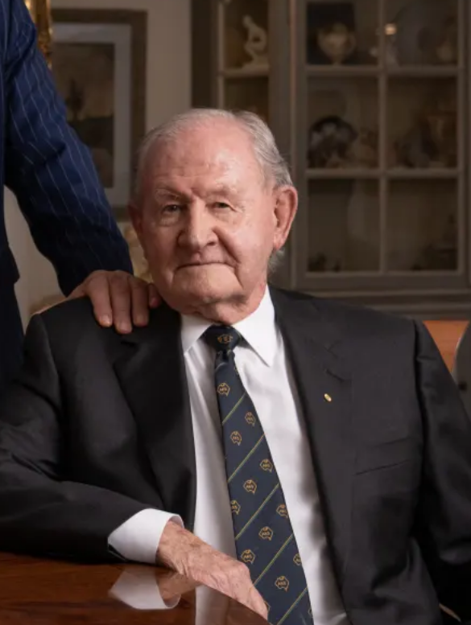
Few will appreciate the hundreds of hours of voluntary time he has given to his craft and profession. His wise counsel in a crisis, knowing when to act and when to leave alone, and his willingness to attend numerous meetings with bureaucrats to explain the clinical realities that an orthopaedic surgeon must confront, will never be fully appreciated. His connections through his clinical reputation with the media have been invaluable in giving a medical perspective to many of the issues making headlines.

Although he treated many high-profile patients and was extremely well-connected across all areas of Australian society, he remained always a humble, personable and caring doctor to all who needed his care.
In his retirement from practice, Dr Cross generously gave of his time to conduct webinars for younger doctors on how to survive in private practice.

From his close connections with the US, Dr Cross anticipated the move to Americanise the Australian healthcare system. At a meeting early in his chairmanship, he handed me a book entitled America’s Health Care Revolution: Who Lives? Who Dies? Who Pays? by Joseph Califano and advised me to read it carefully and prepare for the challenges that were to come. From this commenced the long and ongoing pushback against a corporate takeover of the Australian medical profession.

His deep concern for the suffering of others was underpinned by a strong religious faith and a belief that those with the ability should use it to help others. His many kindnesses to the undersigned will never be forgotten, including introducing me to some of my rugby league heroes through his involvement with the Men of League, and his assistance with my four rugby-playing sons who all regard him as a legend, which he was and always will be.

Rest in peace Dr Merv Cross. We will miss you heaps. We surround your family with our love and support.
This obituary has been kindly provided by ASOS CEO Stephen Milgate AM and can be accessed here.

